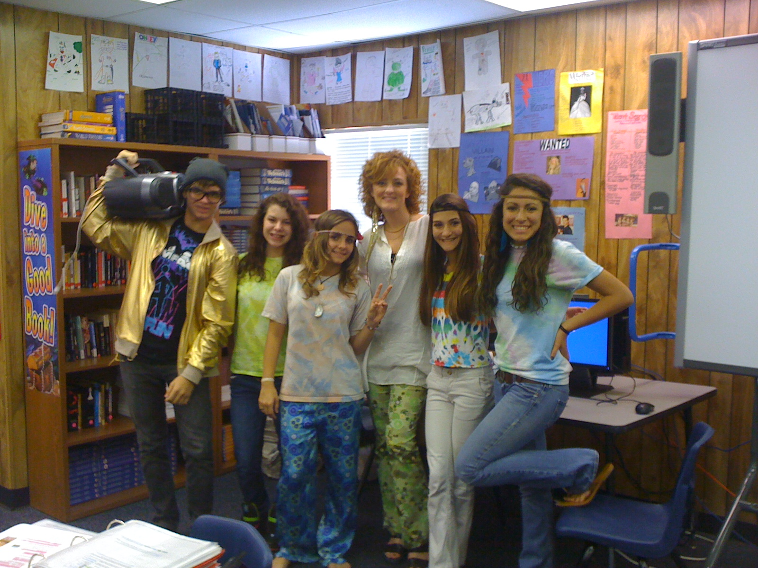 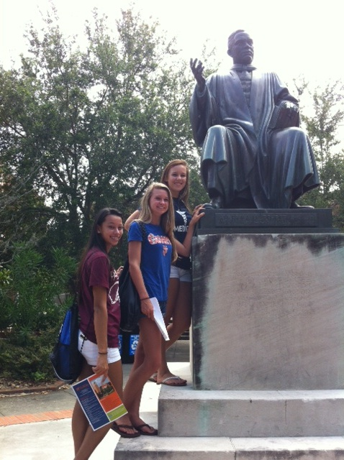 

“It is a class for people who can go farther than what others can. They are people who have a goal, and motivation to get where they want to go.” 10th grader PHUHS

“AVID to me it isn’t just a class, it’s a privilege.” 10th grader PHUHS

“AVID is more than a class to me. It’s a way to my future, my way to a better education.” 9th grader PHUHS

“It makes me feel supported and my classmates are like my family.” 10th grader PHUHS

**UF, USF, UCF, FSU, FGCU, UNF, & UWF to name just a few!**

College Tours

🙞 🙜

# What The Students Say

Palm Harbor University High School

### Kerrale Prince

### [princeke@pcsb.org](mailto:princeke@pcsb.org)

### phuhsavid.weebly.com

AVID

Advancement Via Individual Determination

In AVID we work on preparing students to faces the challenges associated with college.

To start with we work on ACT and SAT preparation, college admission essay writing, college applications, career exploration, college entrance requirements, and college exploration.

We also go on numerous college field trips to help students figure out where they want to apply.

🙞 🙜

## College Preparation

AVID is a college preparation program designed to assist students in achieving their very best! Students will work on skills in the following areas: WICOR, studying, test taking, organizing, note taking, listening, presenting, collaborating, communication, and planning. There are also tutorials twice a week with trained tutors.

AVID students also work extensively on college preparation. This includes examining different colleges, researching criteria for admissions, application preparations, scholarships, and real-life experiences.

AVID is a daily class that students enroll in and counts as an elective. Students also have the unique opportunity to stay in AVID all four years of high school. Every year the program builds and adds to the success of each student. Plus AVID looks great on a college application!

Freshman year the students work on organization, study skills, note taking, presentations, and planning. Sophomore year the students build on those skills and begin working on high-stakes test preparation for ACT/SAT. Students will also examine dual enrollment opportunities and begin to plan for their college experience. Junior year is all about getting ready for college! ACT and SAT are the main focus of the year. Juniors are also required to enter into an AP class. In class we will have AP study groups set-up to assist the students in achieving success. Senior year is entitled Senior Seminar and students will work on life skills, preparing for their college experience, and career exploration.

AVID has really made a huge impact on the students and staff of PHUHS. We look forward to having you and your student as part of our family!

**What are the qualifications to enter AVID at PHUHS?**

Freshmen:

GPA of 2.5 or higher

Honor’s level classes

Sophomores:

GPA of 2.5 of higher

2+ Honor’s level classes

Juniors:

GPA of 2.5 or higher

At least 1 AP class

2+ Honor’s Classes

**How do I apply to AVID?**

Fill-out the application and interview form and return them to Mrs. Prince at PHUHS.

**Where is the application found?**

**Mrs. Prince at** [**princeke@pcsb.org**](mailto:princeke@pcsb.org)**, a guidance counselor, or phuhsavid.weebly.com.**

# Advancement Via Individual Determination

## Q&A